**Lab#1 Web Programming**

CST8285 F2023



LAB OBJECTIVE

The objective of this lab is to get familiar with the following:

1. To create HTML documents using HTML tags
2. Creating a form using HTML form tags
3. Validate your HTML file

# Learning Resources

* Lecture Slides and resources (week 1 - week 3 )
* Complete Lab 0 to install VS code IDE
* HTML Forms: <https://developer.mozilla.org/en-US/docs/Learn/Forms>

Earning

To earn your mark for this lab, each student should finish the lab’s requirements, submit your lab on the Brightspace before the due date and demonstrate the working code to the instructor.

Prelab

Don’t submit the Prelab, you should complete the following tasks before your lab period.

**Inspect Your html File**

1. Open your IDE
2. Create a new folder/directory called *lab1* This is where we are going to store your work.
3. Create a new HTML (“first.html”) document with the following content:

<!DOCTYPE html>

<html lang="en">

<head>

<meta charset="UTF-8">

<title>A very simple webpage</title>

</head>

<body>

<h1>A very simple webpage. This is an "h1" level header. </h1>

<h2>This is a level h2 header. </h2>

<h6>This is a level h6 header. Pretty small!</h6>

<p>This is a standard paragraph.</p>

<h2>How about a nice ordered list!</h2>

<ol>

<li>went to market

<li> went to Web programming class

<li> went to restaurant

</ol>

<h2>Unordered list</h2>

<ul>

<li>First element

<li>Second element

<li>Third element

</ul>

<h2>Nested Lists!</h2>

<ul>

<li>Things to to today:

<ol>

<li>Walk the dog

<li>Feed the cat

<li>Mow the lawn

</ol>

<li>Things to do tomorrow:

<ol>

<li>Lunch with mom

<li>Feed the hamster

<li>Clean kitchen

</ol>

</ul>

</body>

</html>

1. Save your file
2. Open this webpage in **CHROME**
3. Right click on the page and select *View Page Source*
4. Go back to the webpage view Right click on the page and select inspect This should open a little window at the right-hand side of your web page. In Chrome is called the DevTools window.
5. Look at the DevTools window and play with its tabs.

**Validate Your html File**

One way that professional web developers catch errors in their markup is to validate

their documents. What does that mean? To validate a document is to check your markup to make sure that you have abided by all the rules of whatever version of HTML you are using

1. Open a browser and go to <http://validator.w3.org>.
2. In the Validate By File Upload tab, click the Browse or Choose File button and choose your “first.html”file.
3. Click the Check button. The site should eventually verify that your page is valid. You may or may not get a warning, but some of the warning are relatively unimportant.
4. Remove the closing </ul> element, save, and then redo steps 1-3 of this exercise.
5. The page will not be valid, and the service may find not one but many errors. At the time of writing, the validator lists the missing </ul> element as error number 10. Thus, while a validator can help you find an error in your markup, the error messages do take some interpretation.
6. Put the closing </ul> tag back in, save, and re-validate.
7. Try to remove other html tags and re-validate to get familiar with the validator.

Lab Exercise: Create multiple linked html files (**you should submit this part**)

Instructions:

For this lab, I'd like you to create two separate web pages and link them together using HTML.

**Page1:**

This exercise is a great opportunity to showcase your creativity and HTML skills, you'll be creating a web page dedicated to your home town. You can include information like its history, landmarks, culture, and anything that makes it special. Save your page as "hometown.html" on your computer.

* The page should include the following:
* Level-one heading for the town name.
* Level-two heading for the City Information
* Paragraphs
* Image with descriptive alternative text.
* Ordered list
* Unordered list.
* Indent code correctly.
* Validate your page using the [W3C Validator](http://validator.w3.org/). Submit a screenshot for the validation results.

# **Page 2:**

Create a HTML Form named “places.html” that linked to page 1 and meets the following specifications:

• Form is processed by a php file by setting the following attributes:

* method: post
* action: Lab1Form.php
* Specify a name and Id for each form element.
* Use appropriate field size.
* Specify maximum 10 characters for the last name.
* Put your first name as read-only data
* Add a placeholder as shown in the picture below
* You are not allowed to use CSS
* Use the correct form element types. Remember that some of the HTML5 elements look different in different browsers. (The screen captures are from Chrome).
* While I don’t expect your form to look exactly like mine, it should be close the following picture:

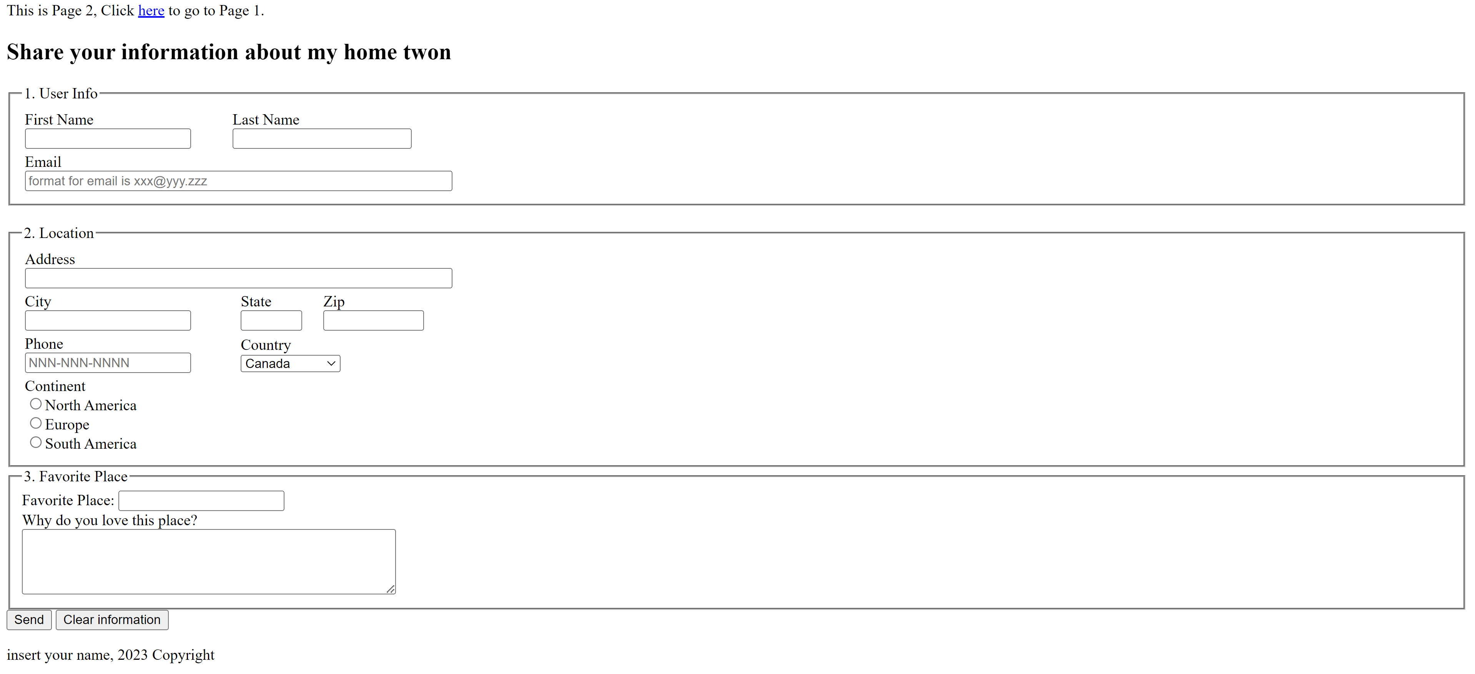

*Figure 1: Form*

* Indent code correctly.
* Validate your page using the [W3C Validator](http://validator.w3.org/). Submit a screenshot for the validation results.

# **Creating a Link**

Now, in Page 1, create a hyperlink to Page 2. Use the <a> (anchor) element and the href attribute to specify the path to Page 2 and Similarly, in Page 2, create a hyperlink back to Page 1.

**Testing**

# Open Page 1 in your web browser and test the link to Page 2. Then, navigate back to Page 1 using the link on Page 2.

**Other Important Requirements**

**All files must include the following:**

* for each page you are to include HTML comments (<!-- HTML Comments -->) that minimally must state your name, the file name, the date the page was created and a brief description of the page's purpose.
* Each page should have a relative hypertext link to the other page at the top of the page as shown in figure 1.
* Any images used on your pages must exist in an images sub-directory, relative to your working directory.

* A header tag element with a title
* Include a different meta tag like the following:

<meta charset="UTF-8">  
  <meta name="description" content="--------">  
  <meta name="keywords" content="---------">  
  <meta name="author" content="-----------">

* A main div that contains A footer with your name, the date, and copyright information as shown in figure 1. Note ***that insert your name*** should be replaced with your first and last name.

# **Submission Instruction**

zip and submit the following files (as a single zip file)

* “hometown.html”
* “places.html”
* An image folder includes all the images you used
* validation screenshot image for each page

The zipped file must be named the following:

<First Name>_<Last Name>.zip

Note that <First Name> and <Last Name> should be replaced with your first and last name.

Submitting .rar file will not be accepted and results in zero marks

Grading

|  |  |
| --- | --- |
| **Criteria** | **points** |
| Creates two html pages “hometown.html” and “places.html”, and there is a Relative hypertext link to the other page. | 1 |
| Includes a level-one heading for the town name | 0.5 |
| Includes a level-two heading for City Information | 0.5 |
| Uses appropriate paragraphs to present information | 0.5 |
| Utilizes an ordered and unordered list for relevant information | 0.5 |
| Send and clear information has corrected functionality | 0.5 |
| Form has appropriate attributes: method and action | 0.5 |
| Name and ID attributes are used for form elements | 0.5 |
| Field size and maximum length specified correctly | 0.5 |
| First name displayed as read-only data | 0.5 |
| Placeholder added for relevant form elements | 0.5 |
| Correct usage of HTML5 form element types | 0.5 |
| Meta Tags | 0.5 |
| Comments include creator's name, file name, date, and describe page's purpose | 0.5 |
| Main div contains a footer with necessary info | 0.5 |
| Form visually resembles the provided example | 2 |
| Images used are located in the "images" sub-directory and all images with descriptive alternative text | 1 |
| Pages are validated using W3C validators | 1 |

To achieve the maximum points, ensure that each requirement is met according to the given instructions.